Tom McVeigh

Contents

Introduction 3

Problem to solve through IoT 3

Investigation of architecture, frameworks, tools, hardware and API 3

Application development plan 4

User Personas 5

User 1: Parent 5

User 2: Teacher 5

User 3: Homeowner 5

Completed Project Screenshots 6

Circuit 6

Code 6

ThingSpeak 8

Output (Twitter) 10

User Tests and Feedback 10

Test 1 10

Test 2 10

Test 3 11

Evaluate feedback showing advantages and disadvantages of the chosen IoT techniques. 11

References 12

# Introduction

This document will cover the design and review of a chosen IoT project. First an Investigation of architecture, frameworks, tools, hardware and API’s will be carried out. Then a problem that these could help solve will be chose. Then the exact choices of Investigation of architecture, frameworks, tools, hardware and API will be made, and an application development plan will be created. After the Project has been created end user tests will be carried out and upon the evaluation of the feedback, advantages and disadvantages will be shown of the IoT techniques used.

# Problem to solve through IoT

The Problem that I have chosen to solve through the use of IoT is people leaving lights on at home. To do this I will be creating a light sensor program that will send the user a text or email after a certain amount of time has passed with the Light being on.

# Investigation of architecture, frameworks, tools, hardware and API

This section will cover IoT architecture, frameworks, tools, hardware and API and what ones I have chosen for the project above. First IoT architecture will be covered. IoT architecture is the way that in which all of the components of the project come together and are designed to be worked into the final product. (1) There are four stages of IoT architecture, the first is Sensors and actuators, then Internet getaways and Data Acquisition systems, then Edge IT and finally Data centre and cloud. The first stage, sensors and actuators, this stage is around sensors gathering information that can be used by the IoT product to produce data, actuators carry out the same tasks but look at data from sources from temperature to light. The second stage Internet getaways and Data Acquisition systems and looks at processing the data from the last stage and compacting it into a way to be easily analysed. The third stage this stage looks at processing and analysing the data previously gotten and looks at turning it in to machine learning or visualisation technologies. The last Stage is that of the data centre. This stage looks at further processing the information and allows for feedback or reviews. (2) There are more types of IoT Architecture including both a smaller three and larger five-layer architecture and another architecture for Cloud computing. (3) For this project I will be using the four-layer architecture that was discussed first.

Next frameworks will be covered. These are ways that the structure of the product is created. There are 4 parts to frameworks. Hardware, software, Communication and Cloud. Hardware needs the architecture previously discussed along with the hardware required like sensors or controllers. Software requires programs created to configure the hardware and get the results required. Communication relates to the wired and wireless forms of communication to send information such as cloud. The cloud section looks at physical and cloud components working together to carry out the tasks required. (4) There are many examples of frameworks for IoT. The first is DeviceHive, this is a open source IoT management service that supports a wide range of client libraries, is scalable And can connect to devices through a range of API’s. The next framework is Thing speak, this is a IoT platform that works with and uses data from MathWorks to give data analysis from multiple different devices with different information. The final framework that will be covered is Zetta, this is a free IoT framework that allows for a constant stream of data but doesn’t have any way to visualise the data. (5) Out of the covered frameworks the one that I will be using is Thing speak as it offers the most useful features for the current project and also is one that I have previous experience with.

Next IoT tools will be covered. IoT tools are networks or connected devices that carry out tasks. The devices that are used as these tools include tessel 2, Arduino and Raspbian. Tessel 2 is a board to build IoT prototypes, it has ethernet and wifi connectivity as well as more modules that can be added if needed such as a camera or accelerometers. Next, Arduino is a microcontroller board and is an easy to use board for IoT beginners. Lastly is Raspbian, this is an IDE created for the raspberry pi single board computer. It allows for the use of precompiled software and has rapid installation. (6) The tool that I will be using for this project is that of Raspbian as the project will be built using a raspberry pi unit.

Next, Hardware will be covered. IoT hardware is the hardware required to carry out the tasks required and set out by the software that the user creates. This can include the previously discussed boards like the raspberry pi or more components that may need to be added such as sensors or controllers. A few examples components are, Light sensors, accelerometers, pressure sensors, level sensors, noise sensors and temperature sensors. The ones that would be needed for the project above would be capacitors, cables and a Light sensor, as well as the raspberry pi unit. (7)

The last section to be covered is API’s. An IoT API is an application programming interface and are how the IoT devices connect to the internet. (8) An example of an API is the REST API it stands for Representational state Transfer. It isn’t a protocol, but it is a concept. It can be used with JSON or XML Scripts with HTTP. REST follows methods used by HTTP specification to perform actions that can are similar to SQL, like POST, GET, PUT and DELETE. As a result of this, REST will be used with the current project. (9)

# Application development plan

|  |  |  |  |  |
| --- | --- | --- | --- | --- |
| Task | Purpose | Date Started | Date Finished | Complete? |
| Create Circuit | To create the hardware needed for the Project | 22/03/2020 | 23/03/2020 | 25% |
| Write Code | To create the software needed for the Project | 15/03/2020 | 24/03/2020 | 50% |
| Test Code and Circuit | To make sure that there are no problems that will break completed Project | 24/03/2020 | 24/03/2020 | 0 |
| Upload to Thing Speak | To upload the information to be processed | 24/03/2020 | 24/03/2020 | 0 |
| Get Response | To show that the project works and to get the response needed | 24/03/2020 | 24/03/2020 | 0 |

# User Personas

## User 1: Parent

Level of Computer knowledge: Moderate

Reason for using the product: To see if children are up past when they are supposed to be.

Process of using this product: Place the product in either the living room, kitchen or other room where children may visit and wait until a light is turned on. This will then send a notification to the user alerting them that their children may be awake.

## User 2: Teacher

Level of Computer knowledge: High

Reason for using the product: To see when students are entering their Classroom.

Process of using this product: Place device in the classroom and leave to carry out any business needed. Then an alert will be sent via twitter alerting them that the classroom light is on and students may be showing for class.

## User 3: Homeowner

Level of Computer knowledge: Moderate

Reason for using the Product: To see if lights have been left on.

Process of using this product: Place the device in a room where lights are frequently left on and then go about your day. When needed check your twitter to see if there are any recent posts by the sensors page, if so, a light has been left on and needs to be turned off.

# Completed Project Screenshots

## Circuit

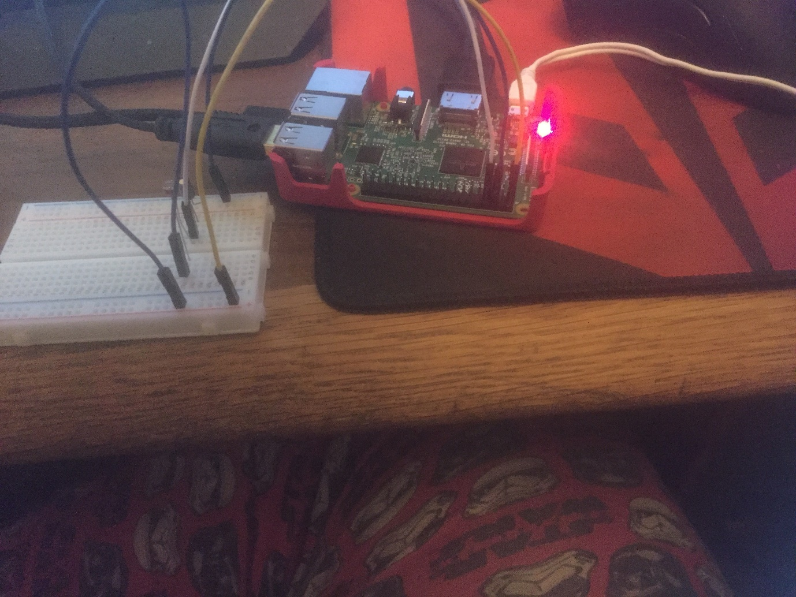

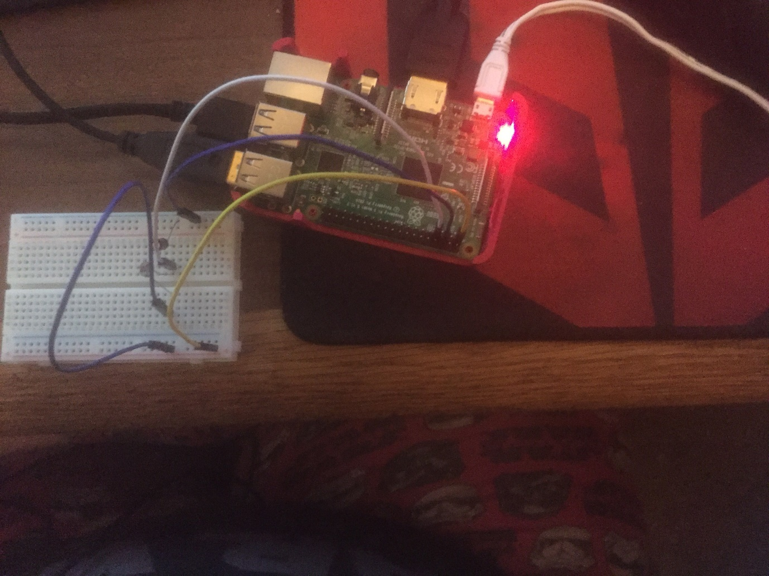

## Code

import RPi.GPIO as GPIO

import time

import http.client

import urllib

GPIO.setmode(GPIO.BOARD)

GPIO.setwarnings(False)

#define the pin that goes to the circuit

pin_to_circuit = 7

light = 0

key = '9RDMH4LWUZLIG7X0'

baseURL = 'https://api.thingspeak.com/update?api_key=9RDMH4LWUZLIG7X0&field1=0'

def read(pin_to_circuit):

count = 0

GPIO.setup(pin_to_circuit, GPIO.OUT)

GPIO.output(pin_to_circuit, GPIO.LOW)

time.sleep(0.1)

GPIO.setup(pin_to_circuit, GPIO.IN)

while (GPIO.input(pin_to_circuit) == GPIO.LOW):

count += 1

return count

def sendread():

light = read

time.sleep(1)

params = urllib.parse.urlencode({'field1': light, 'key':key })

headers = {"Content-typZZe": "application/x-www-form-urlencoded","Accept": "text/plain"}

conn = http.client.HTTPConnection("api.thingspeak.com:80")

try:

conn.request("POST", "/update", params, headers)

response = conn.getresponse()

print (light)

print (response.status, response.reason)

data = response.read()

conn.close()

except:

print ("connection failed")

if name == "main":

while True:

sendread()

time.sleep(1)

## ThingSpeak

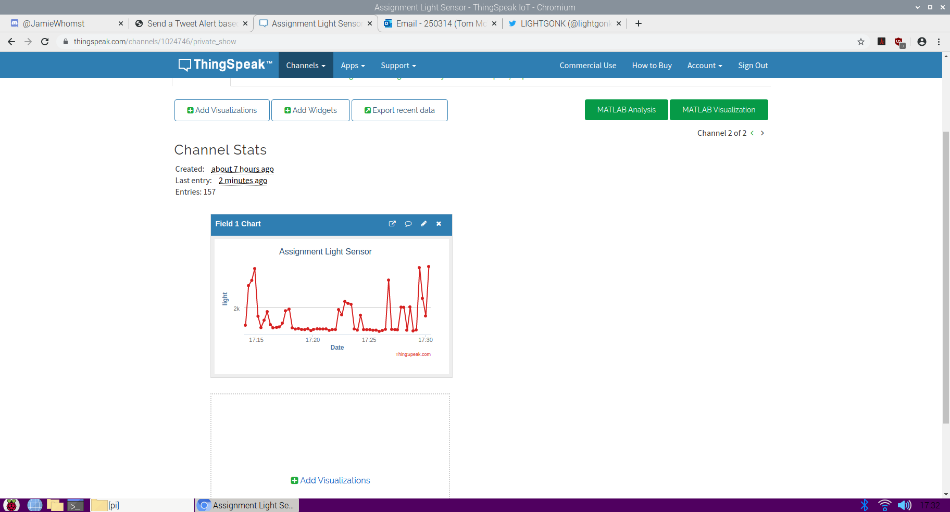

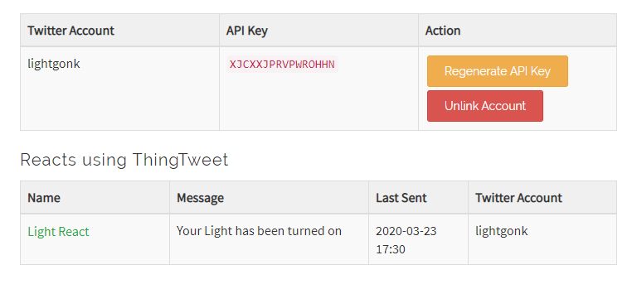

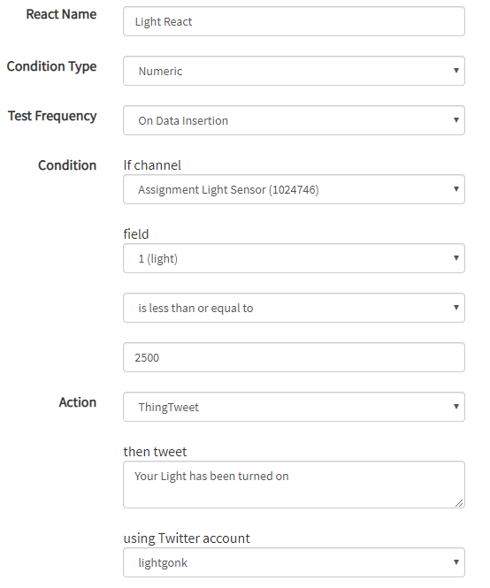

## Output (Twitter)

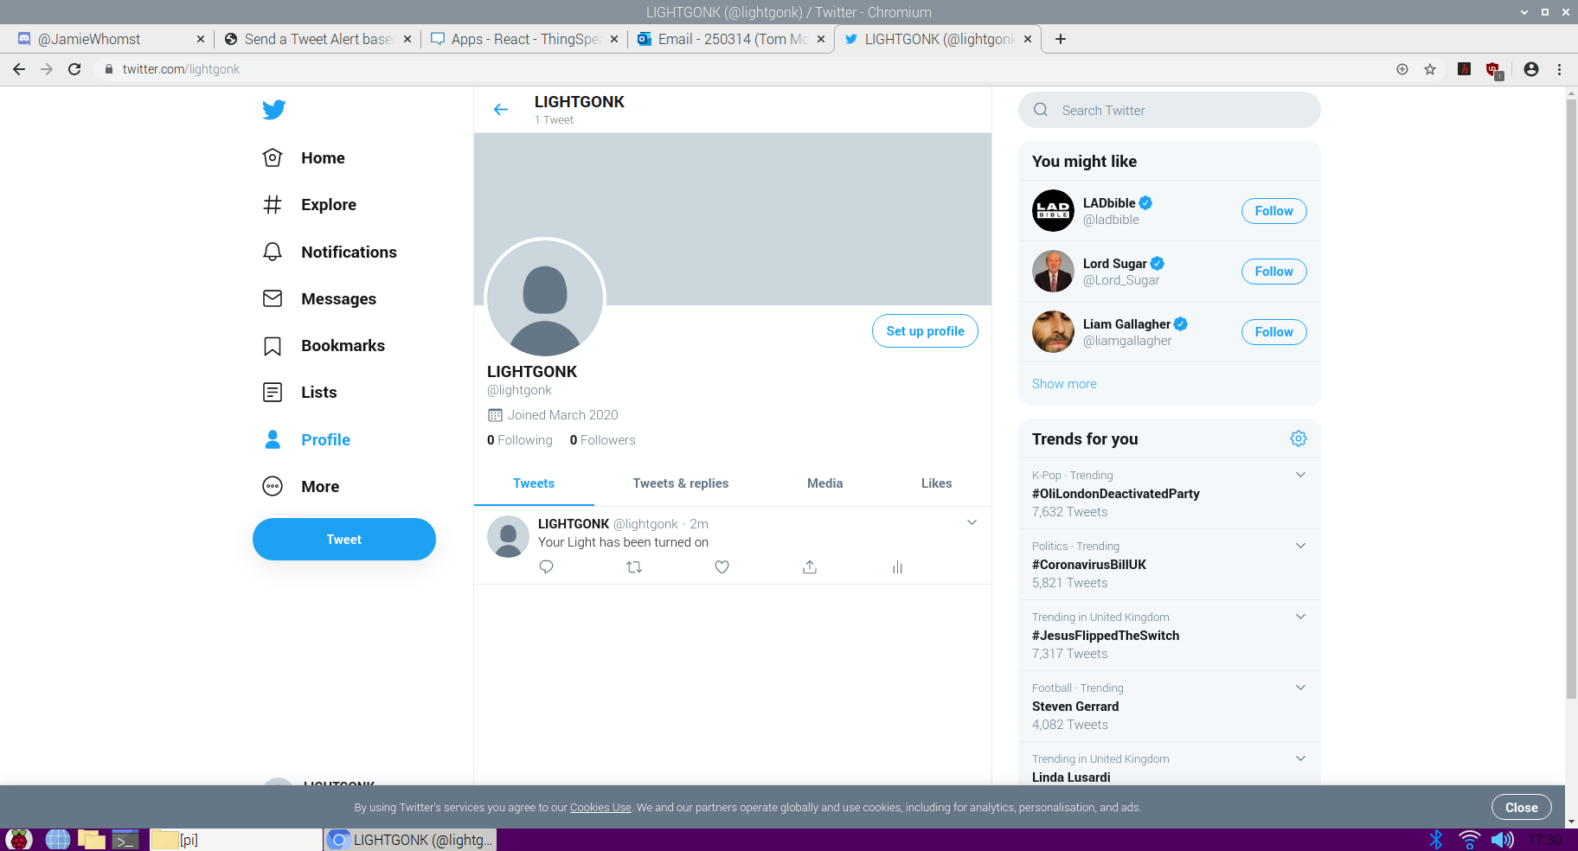

# User Tests and Feedback

To test the end product, I asked three people to test the program and to give their feedback.

## Test 1

Tester: Nichola McVeigh (Parent) Date: 25/03/2020

Purpose for using the Product: To make sure that all lights are turned off after a certain time.

How was this tested: I turned on the sensor and left it in the living room, and it allowed me to see if any one was up at a time that they shouldn’t be.

Was the test successful: Yes, it alerted me to someone turning on lights.

Any suggested improvements: Yes, an improvement to how long light must be present for to send the notification as a few times it picked up passing cars.

## Test 2

Tester: Stephen McVeigh (University Lecturer) Date: 25/03/2020

Purpose for using the Product: To see when someone turns on a light in my classroom.

How this was Tested: I turned on the product and left it in my classroom and waited to see the twitter notification for when the light it turned on.

Was the test Successful: Yes

Any Suggested Improvements: Change the method of notification, a text or email would be better and easier to receive.

## Test 3

Tester: Terence Jones (Homeowner) Date: 25/03/2020

Purpose for using the Product: I wanted to use this product to see if I could be reminded to turn off any lights that I forgot to turn off.

How this was Tested: I left this device in my living room and forgot about it, until I later checked my social media and saw the notification saying it was still on.

Was the test Successful: Yes, it was.

Any Suggested Improvements: Make the notification more direct. Preferably a text or email.

# Evaluate feedback showing advantages and disadvantages of the chosen IoT techniques.

From the feedback gathered from the tests carried out I can see that using thing speak was a good idea as it allowed me to send a notification to the users that they could see and react to once the sensor gave a certain reading. Thing speak also had a disadvantage in the amount of time between notifications as there are only set periods of time or as soon as the data is put in, this makes it difficult for people to use if they want an update every 5 minutes. With using the Light sensor, it allowed me to create a product that can be used by anyone in multiple different ways, as reflected in the feedback. When using the twitter addon for thing speak, it has its advantages, like allowing for notifications to be sent to people on any device at any time. But it also has a disadvantage of people having to go out of their way to use social media, which could lead to them being distracted. A better solution for this would have been to send a text or email, as these are things that the majority of people have access to and can be accessed with out leading to the user being distracted.

# References

1. Gupta A. What is IoT architecture?. Quora. 2020. [accessed 20 Mar 2020] Available from: <https://www.quora.com/What-is-IoT-architecture>
2. 4 Stages of IoT architecture explained in simple words. Medium. 2020. [accessed 20 Mar 2020] Available from: <https://medium.com/datadriveninvestor/4-stages-of-iot-architecture-explained-in-simple-words-b2ea8b4f777f>
3. IoT Architectures. Hindawi. 2020. [accessed 20 Mar 2020] Available from: <https://www.hindawi.com/journals/jece/2017/9324035/>
4. What are IoT Frameworks?. Quora. 2020. [accessed 20 Mar 2020] Available from: <https://www.quora.com/What-is-IoT-platform-and-framework>
5. 5 Best Open Source IoT Frameworks | ByteAnt. Byteant.com. 2020. [accessed 20 Mar 2020] Available from: <https://www.byteant.com/blog/5-best-open-source-iot-frameworks/>
6. IoT Tools | Concept and a Few Popular IoT Development Tools. EDUCBA. 2020. [accessed 20 Mar 2020] Available from: <https://www.educba.com/iot-tools/>
7. Team D. IoT Hardware | IoT Software - A Complete Tour - DataFlair. DataFlair. 2020. [accessed 20 Mar 2020] Available from: <https://data-flair.training/blogs/iot-hardware/>
8. Hill K, Hill K. What is an IoT API? - RCR Wireless News. RCR Wireless News. 2020. [accessed 20 Mar 2020] Available from: <https://www.rcrwireless.com/20161018/internet-of-things/what-is-an-iot-api-tag6-tag99>
9. IoT is Eating the World: APIs and REST. IoT For All. 2020. [accessed 20 Mar 2020] Available from: <https://www.iotforall.com/iot-rest-api/>